CLOUD COMPUTING LAB: LAB 11

PES1201802127

Siddharth K Rao

1. Explore the users and groups

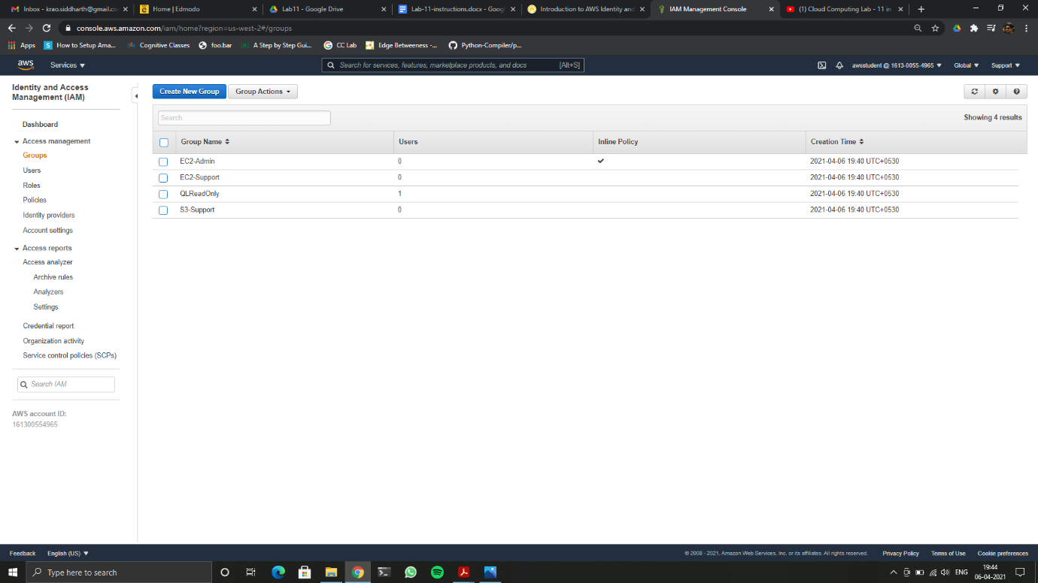

List of groups showing that they have zero users in each group

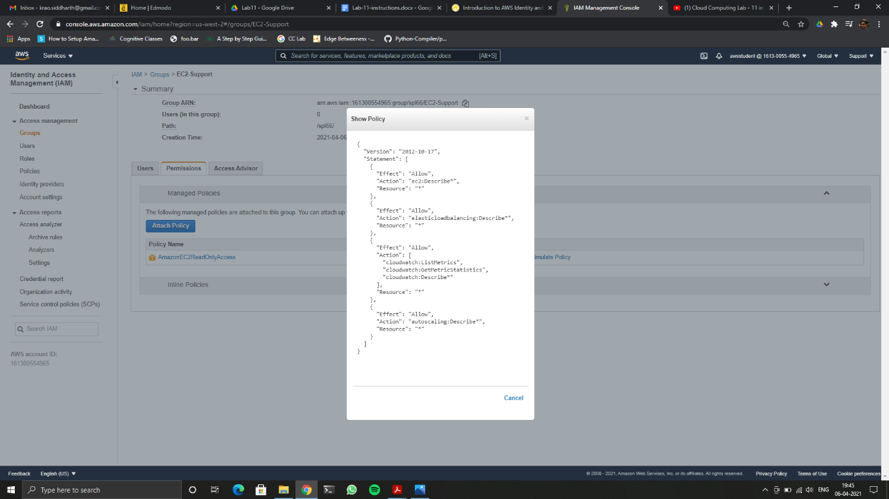

Showing policy for EC2-Support group

1. Add users to the groups

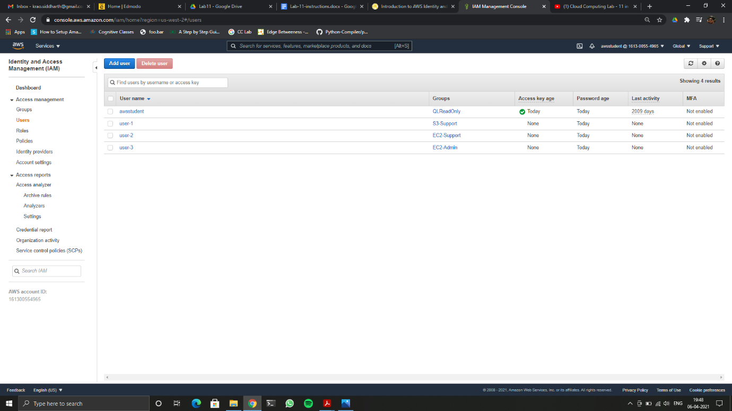

Showing each user with the groups they have been added to

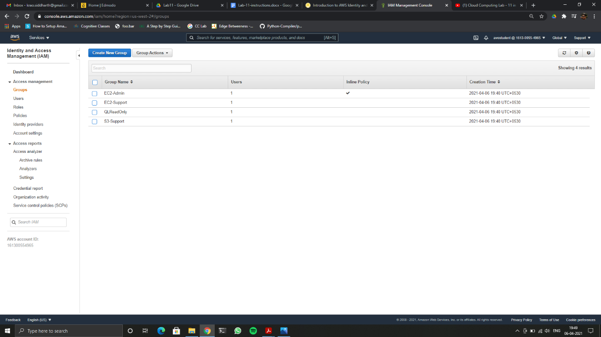

Showing each group having one user

1. Testing user access

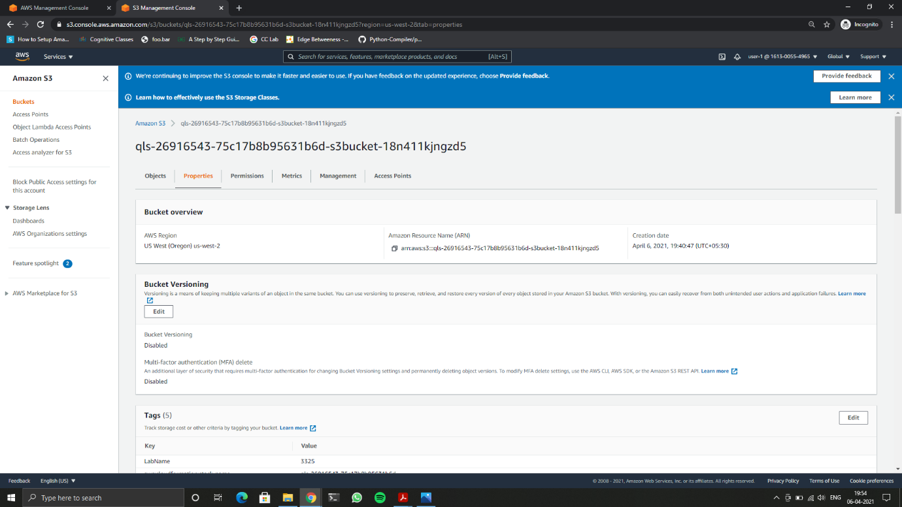

Showing User-1 having access to view details S3-Bucket

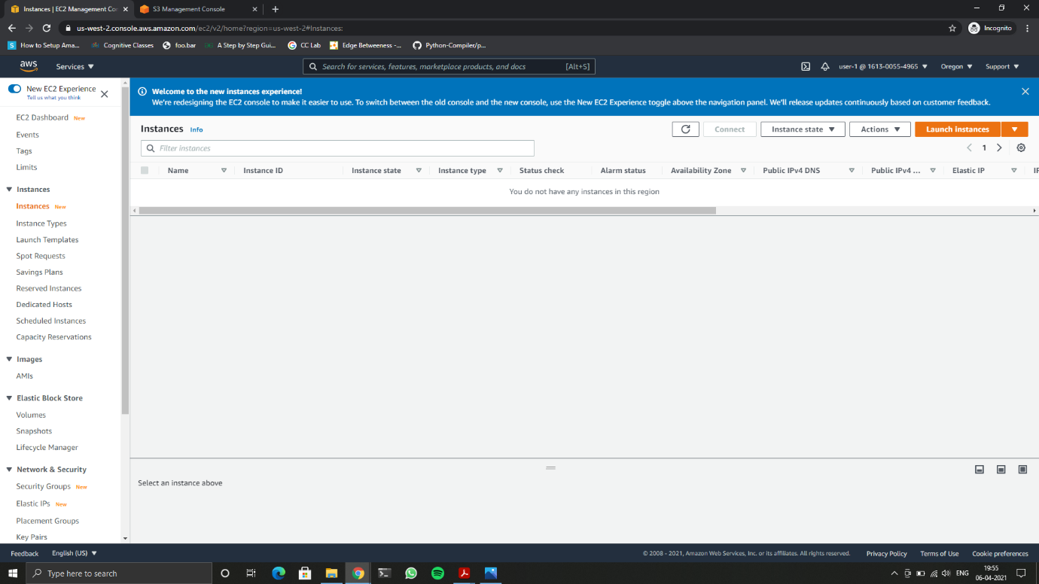

Showing User-1 having NO access to view details EC-2 Instances

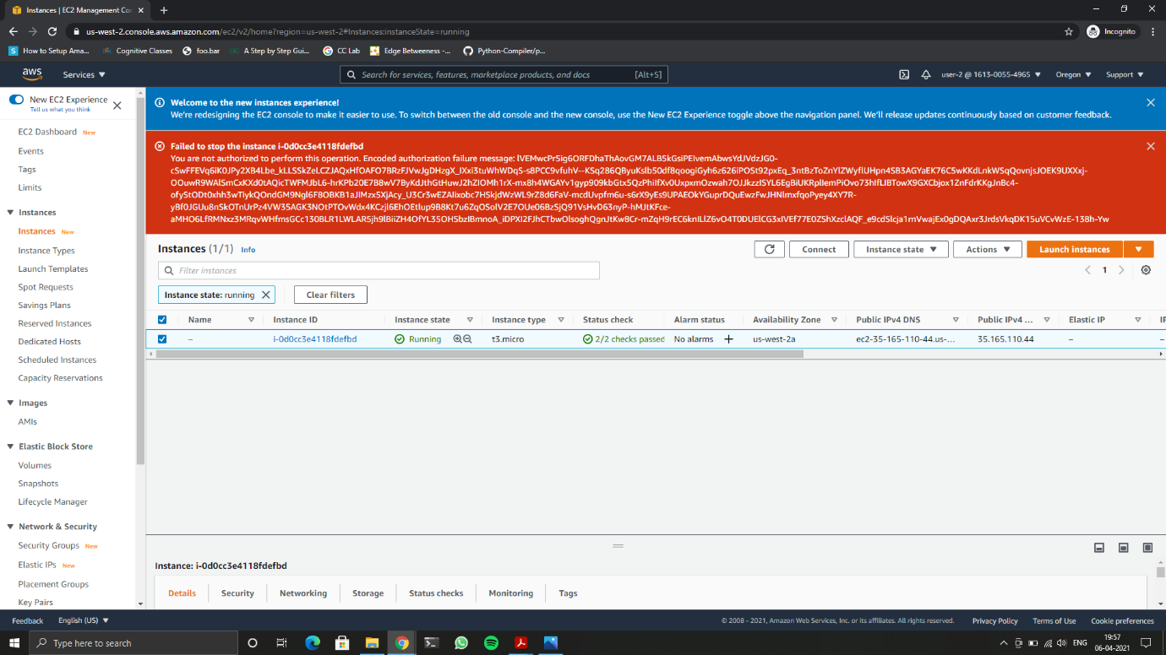

Showing User-2 having access view details EC-2 Instances, but not able to stop instance

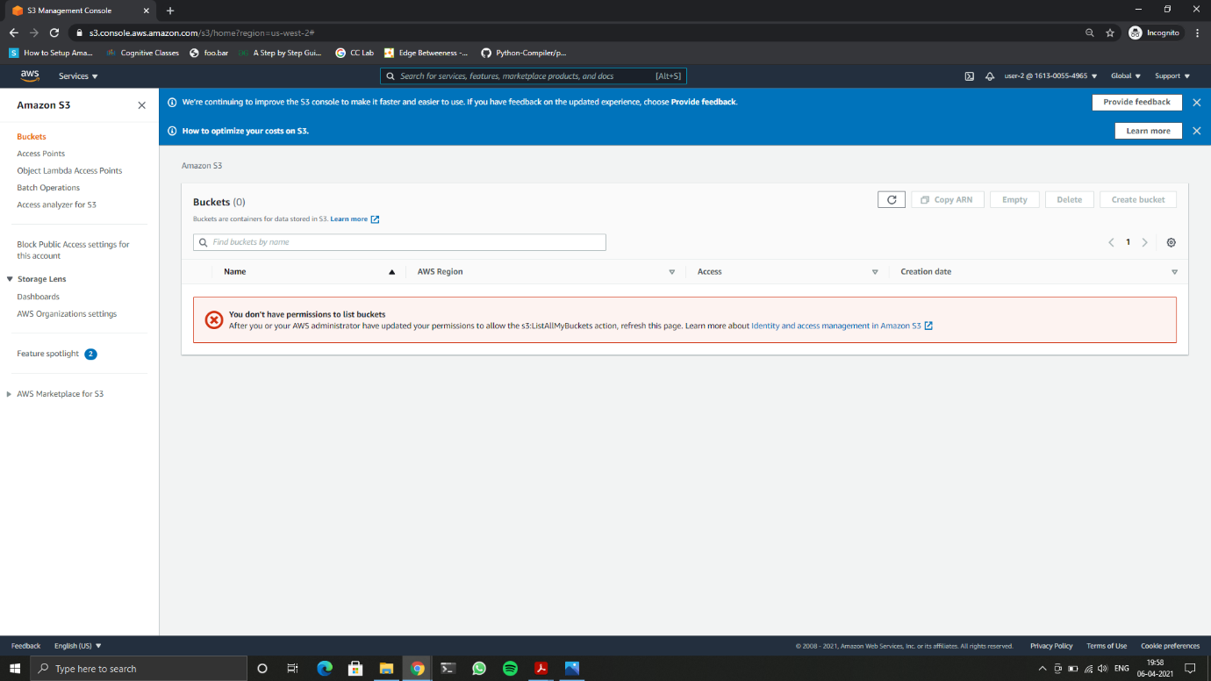

Showing User-2 having NO access view details S3-Bucket

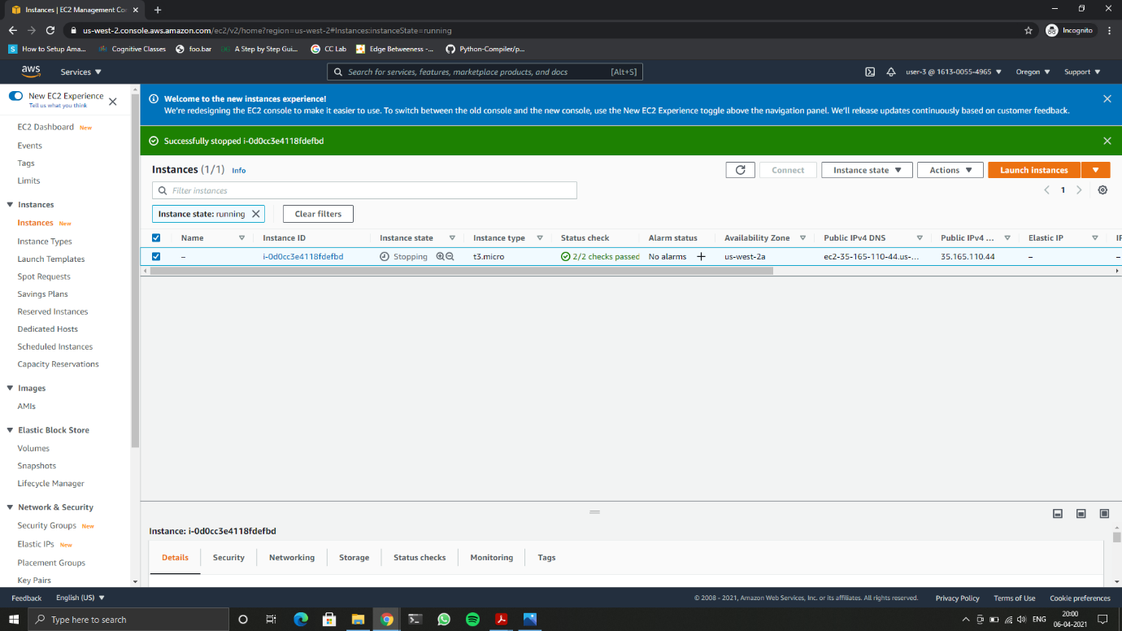

Showing User-3 having able to stop instance, since the user is a admin

